These functions not working
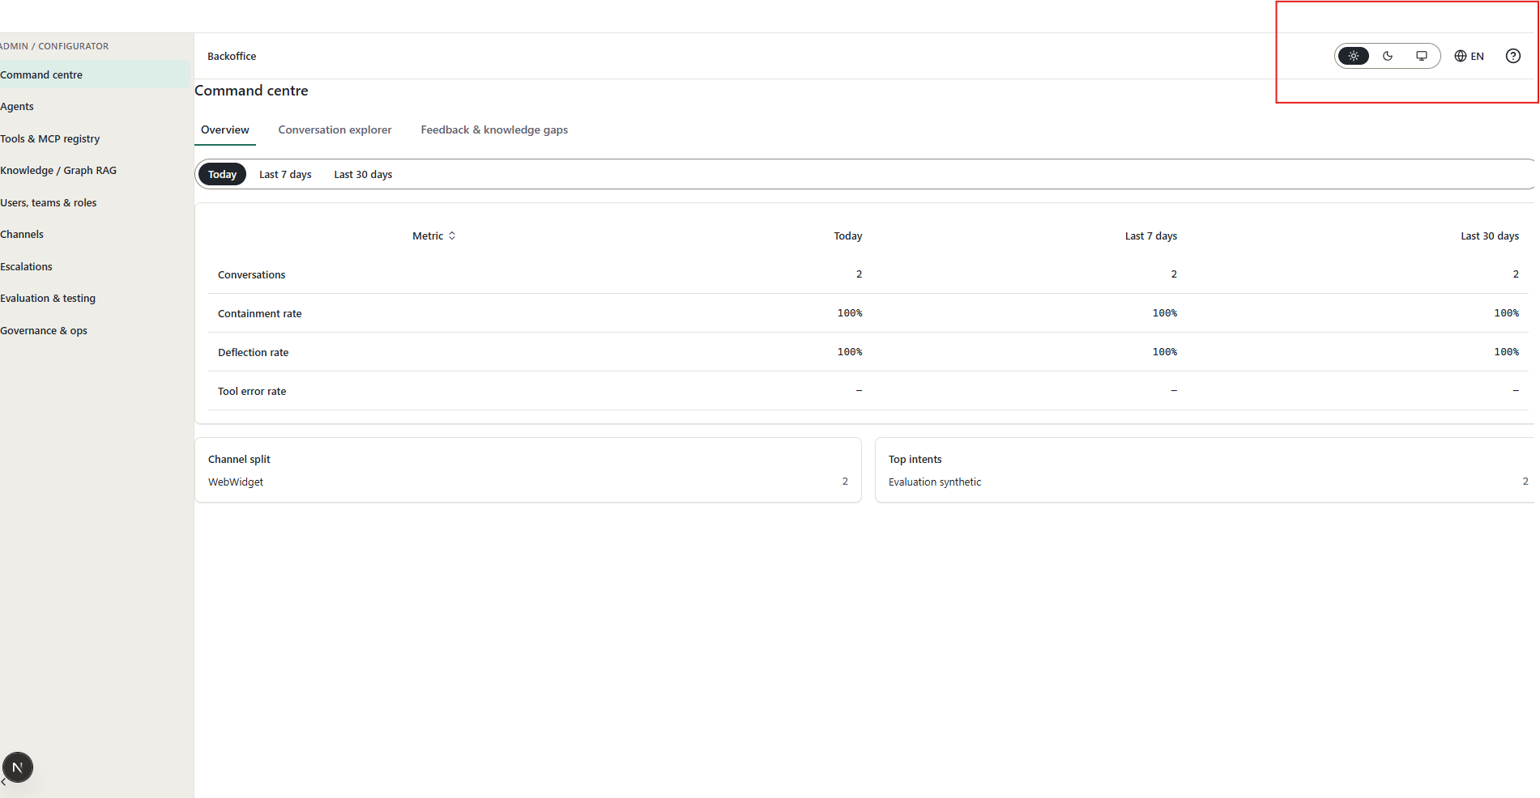
Some functions like this desnt have complete features like add new in the below screen
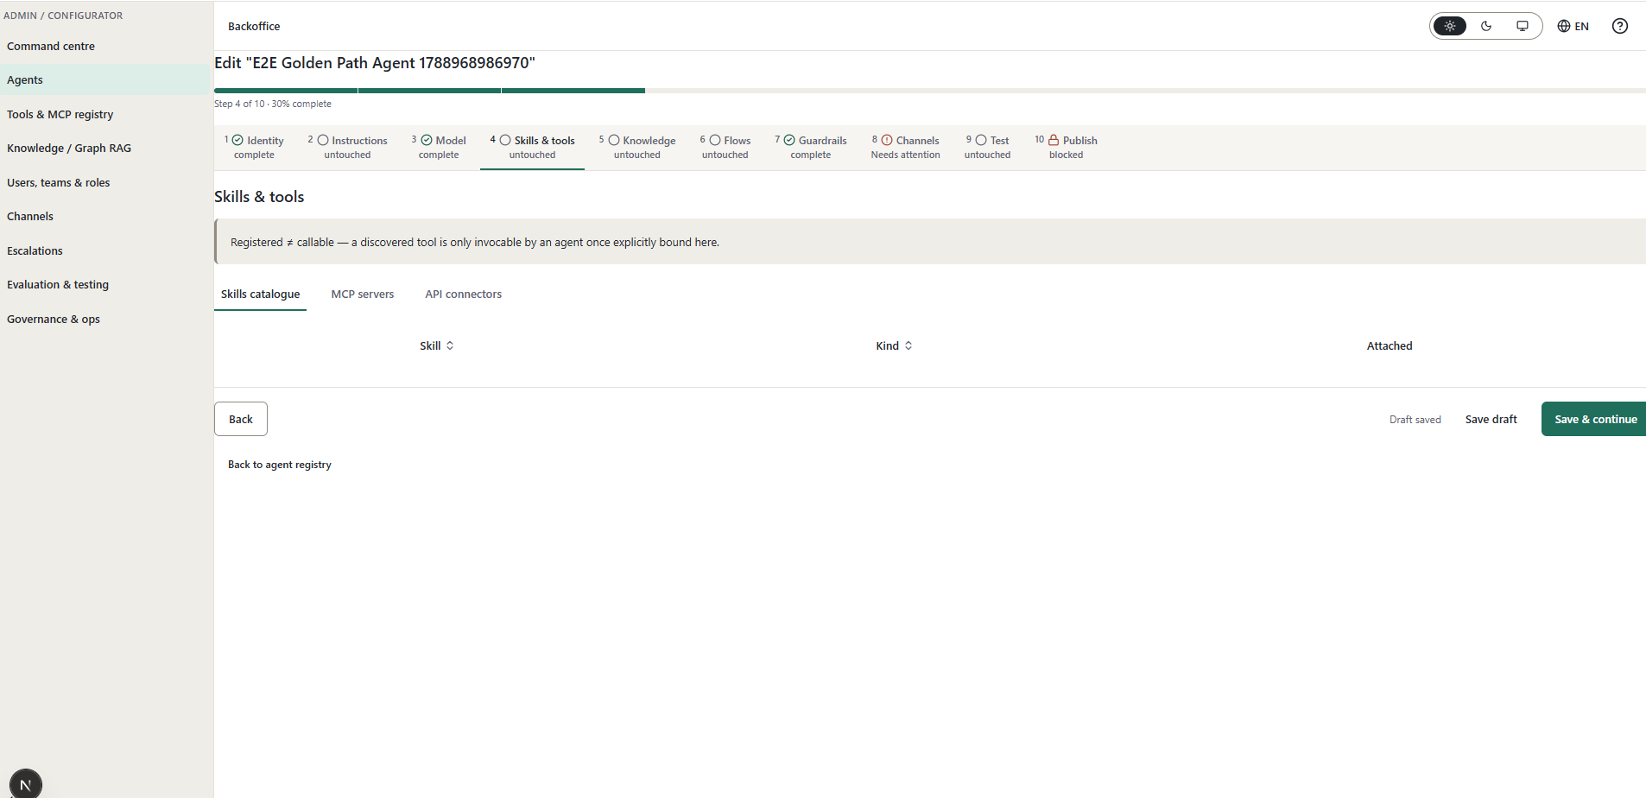
Many cases like this (“MCP servers”,’’,.)
Example
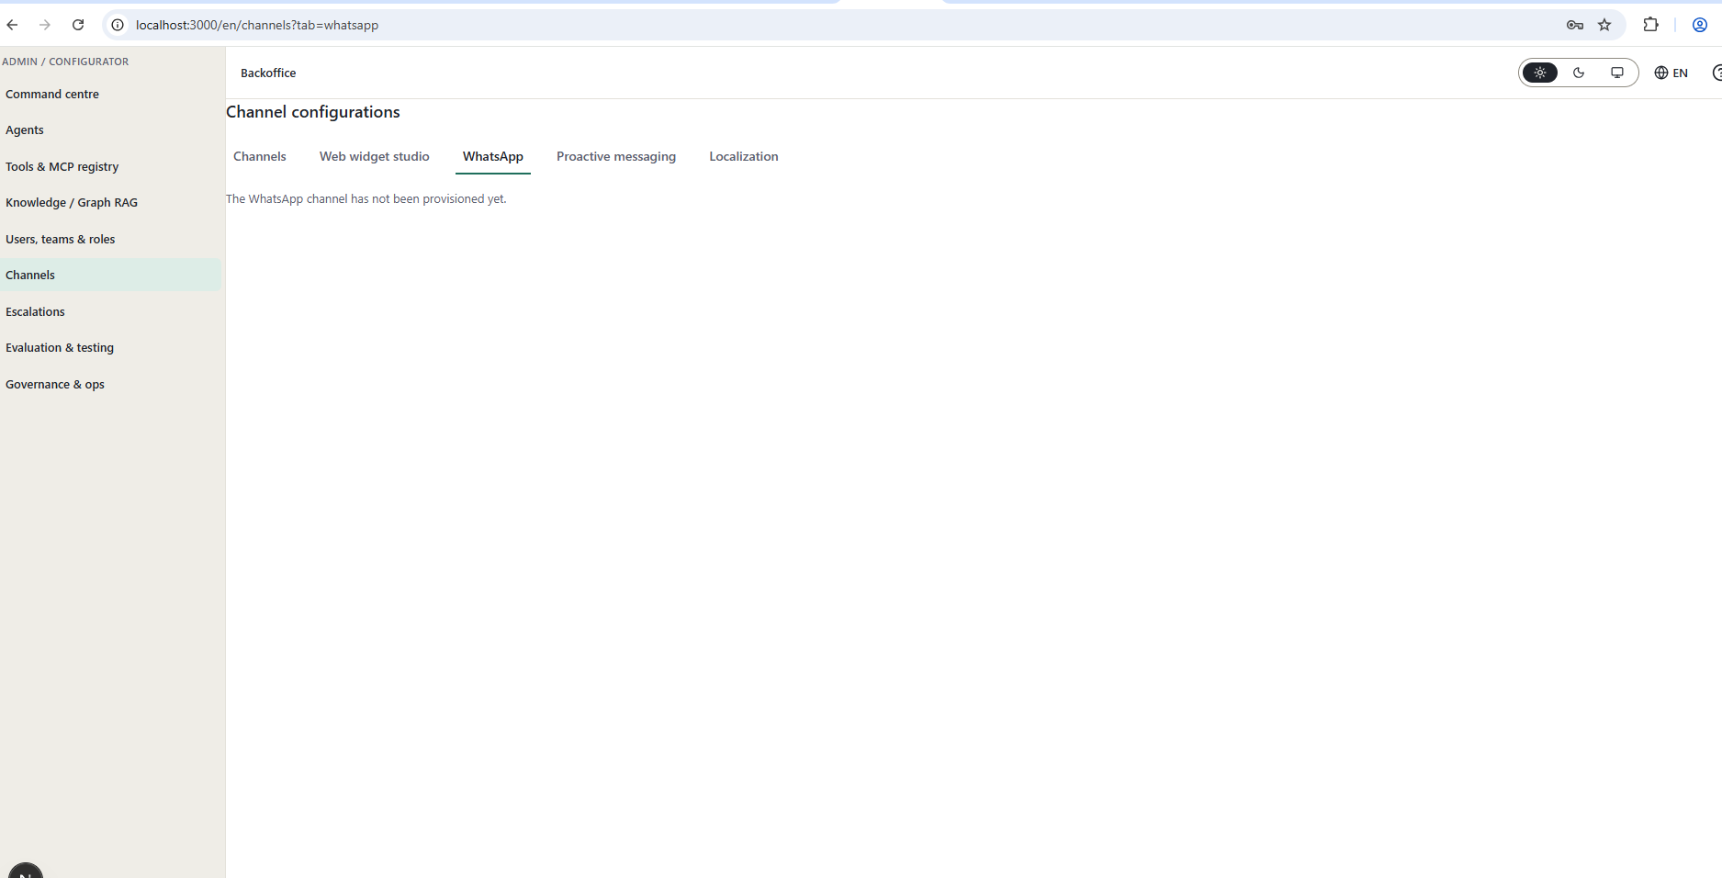
How I can connect whatsapp and so on
Validate alls screen

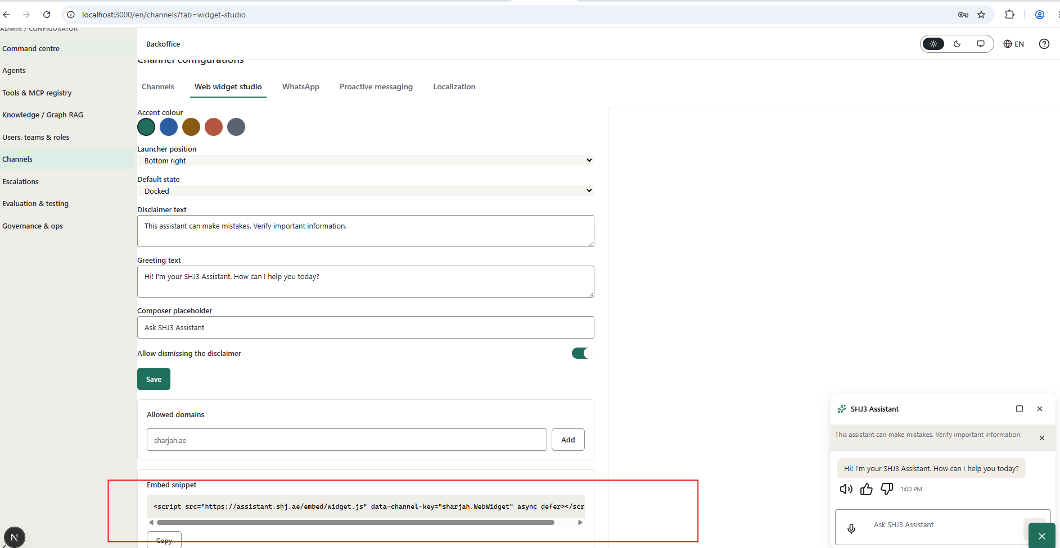
This snippt should has the right js url

